Figure 1.1
Graph of resistance against temperature.
How resistance is affected by temperature.
The resistance of conductor changes with the size where the thicker conductor has less resistance compared to thinner resistance, which has higher resistance. The resistance of any conductor is also affected by change temperature. Change in temperature will expand or contracts the dimension of the conductor (Yoshihara 2018, p10). Conductor's material increases their resistance with an increase in temperature while insulators material tends to decrease their resistance with an increase in temperature. Example of effective insulators includes plastics and glass.
The changes in temperature cause expansion and contraction of the conductor. The atomic structure of the conductor determines the rate of change o the conductor. The flow of current in the conductor is determined by the resistivity of the conductor (Cheng et al. 2015, p 107). The flow of current is the movement of electrons from one atom to another in an electric field. Therefore, the electrical potential must be applied across the end of the conductors such that positive on one end and negative at the other end, thus making electrons to move from one atom to another (Cheng et al. 2015, p 107).
Change of the heat on the atomic structure makes the atom vibrate, and when the temperature increase, more vibration occurs. The conductors that have a positive temperature coefficient the resistances increase with the rise in temperature while when the resistances decrease with an increase in temperature, the conductor has a negative temperature coefficient. Conductors have a positive temperature coefficient, while the insulators have a negative temperature coefficient (Bose, 2017, p 24).
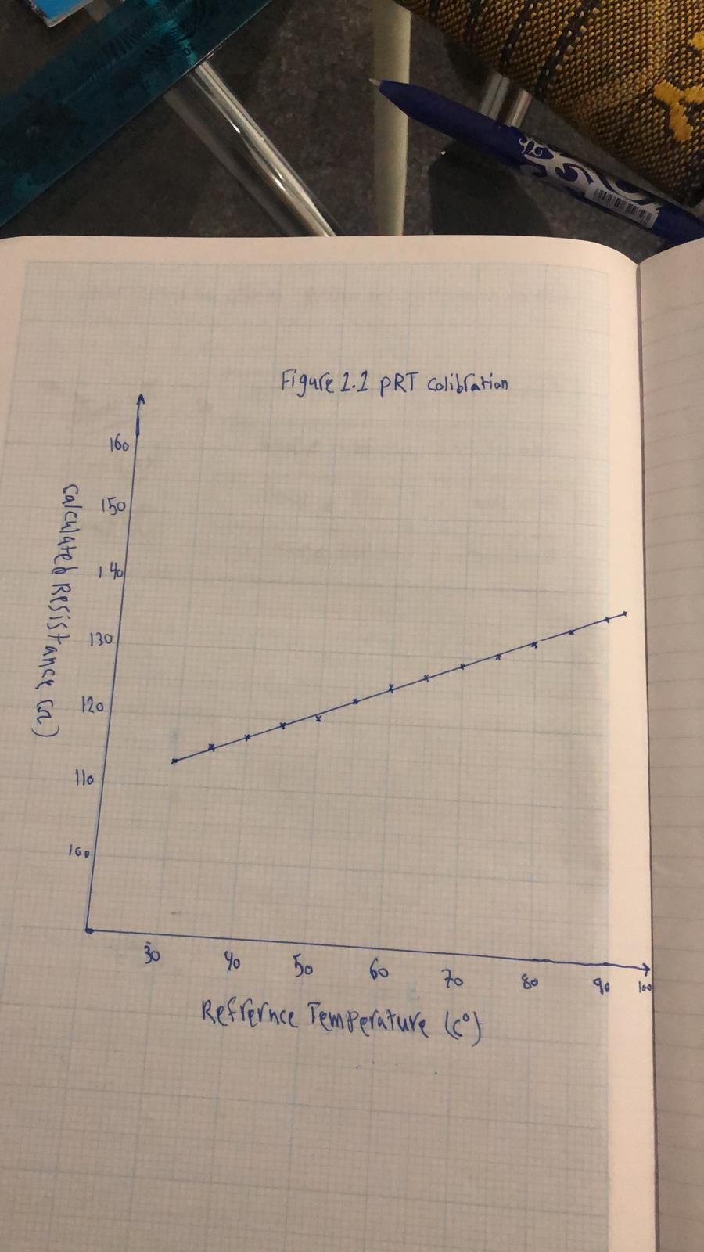
In this graph, the resistances are plotted on the y-axis while the change in temperature is plotted on the x-axis. The material used is a conductor because the increase in temperature increases the resistance.
Calculating the coefficient of resistance and temperature.
( 30, 113.5) (70, 128.9)
$\frac{70-30}{128.9-113.5}$ = 2.6, meaning that the material has a positive temperature coefficient.
When the temperature is at 30 degrees, the resistances are at 113.5, and when the temperature increases to 70, the resistances increase to 128.9. Therefore, the increase in temperature increases the resistance of the conductor.
The deviation of resistance changes, but it increases with the increase in temperature. The resistance deviation is very high when the heat is high. The error is calculated in percentage in which it changes down as the temperature increases.

References.
Yoshihara, T. and TAKEMURA, M., Shibaura Electronics Co Ltd, 2018. Temperature sensor and temperature sensor manufacturing method. U.S. Patent 10,156,483.

Cheng, Z., Liu, L., Xu, S., Lu, M., and Wang, X., 2015. Temperature dependence of electrical and thermal conduction in the single silver nanowire. Scientific reports, 5, p.10718.
Bose, S., 2017. High-temperature coatings. Butterworth-Heinemann.

